CS 255 System Design Document Template

UML Diagrams

UML Use Case Diagram
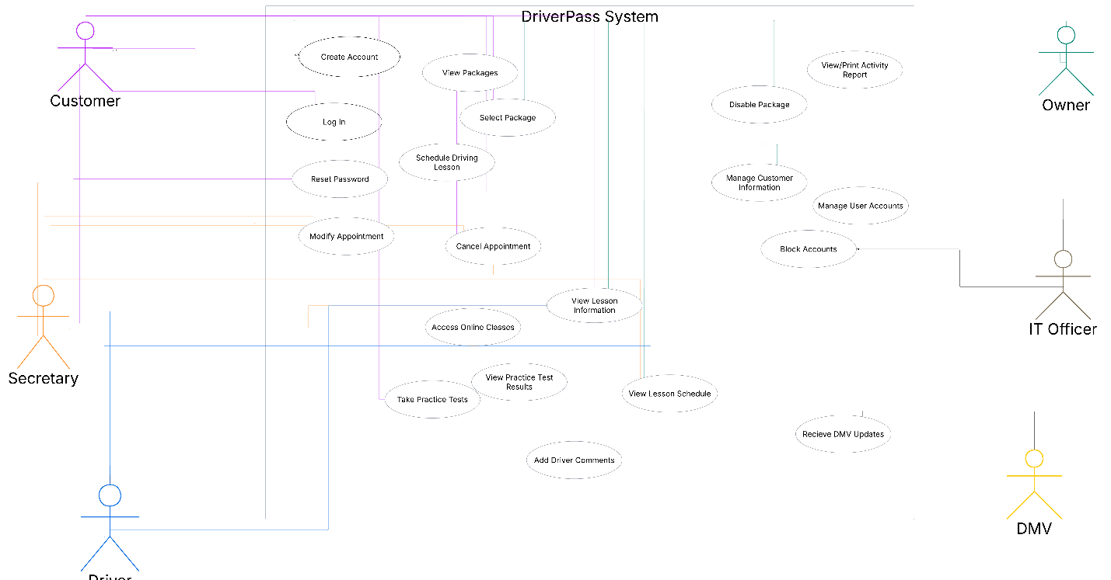

UML Activity Diagrams
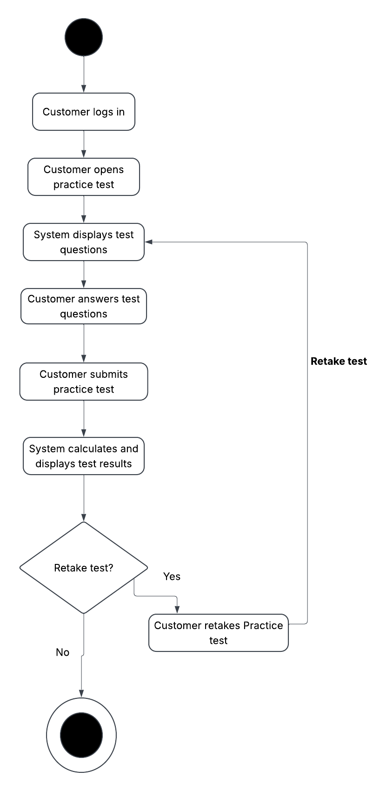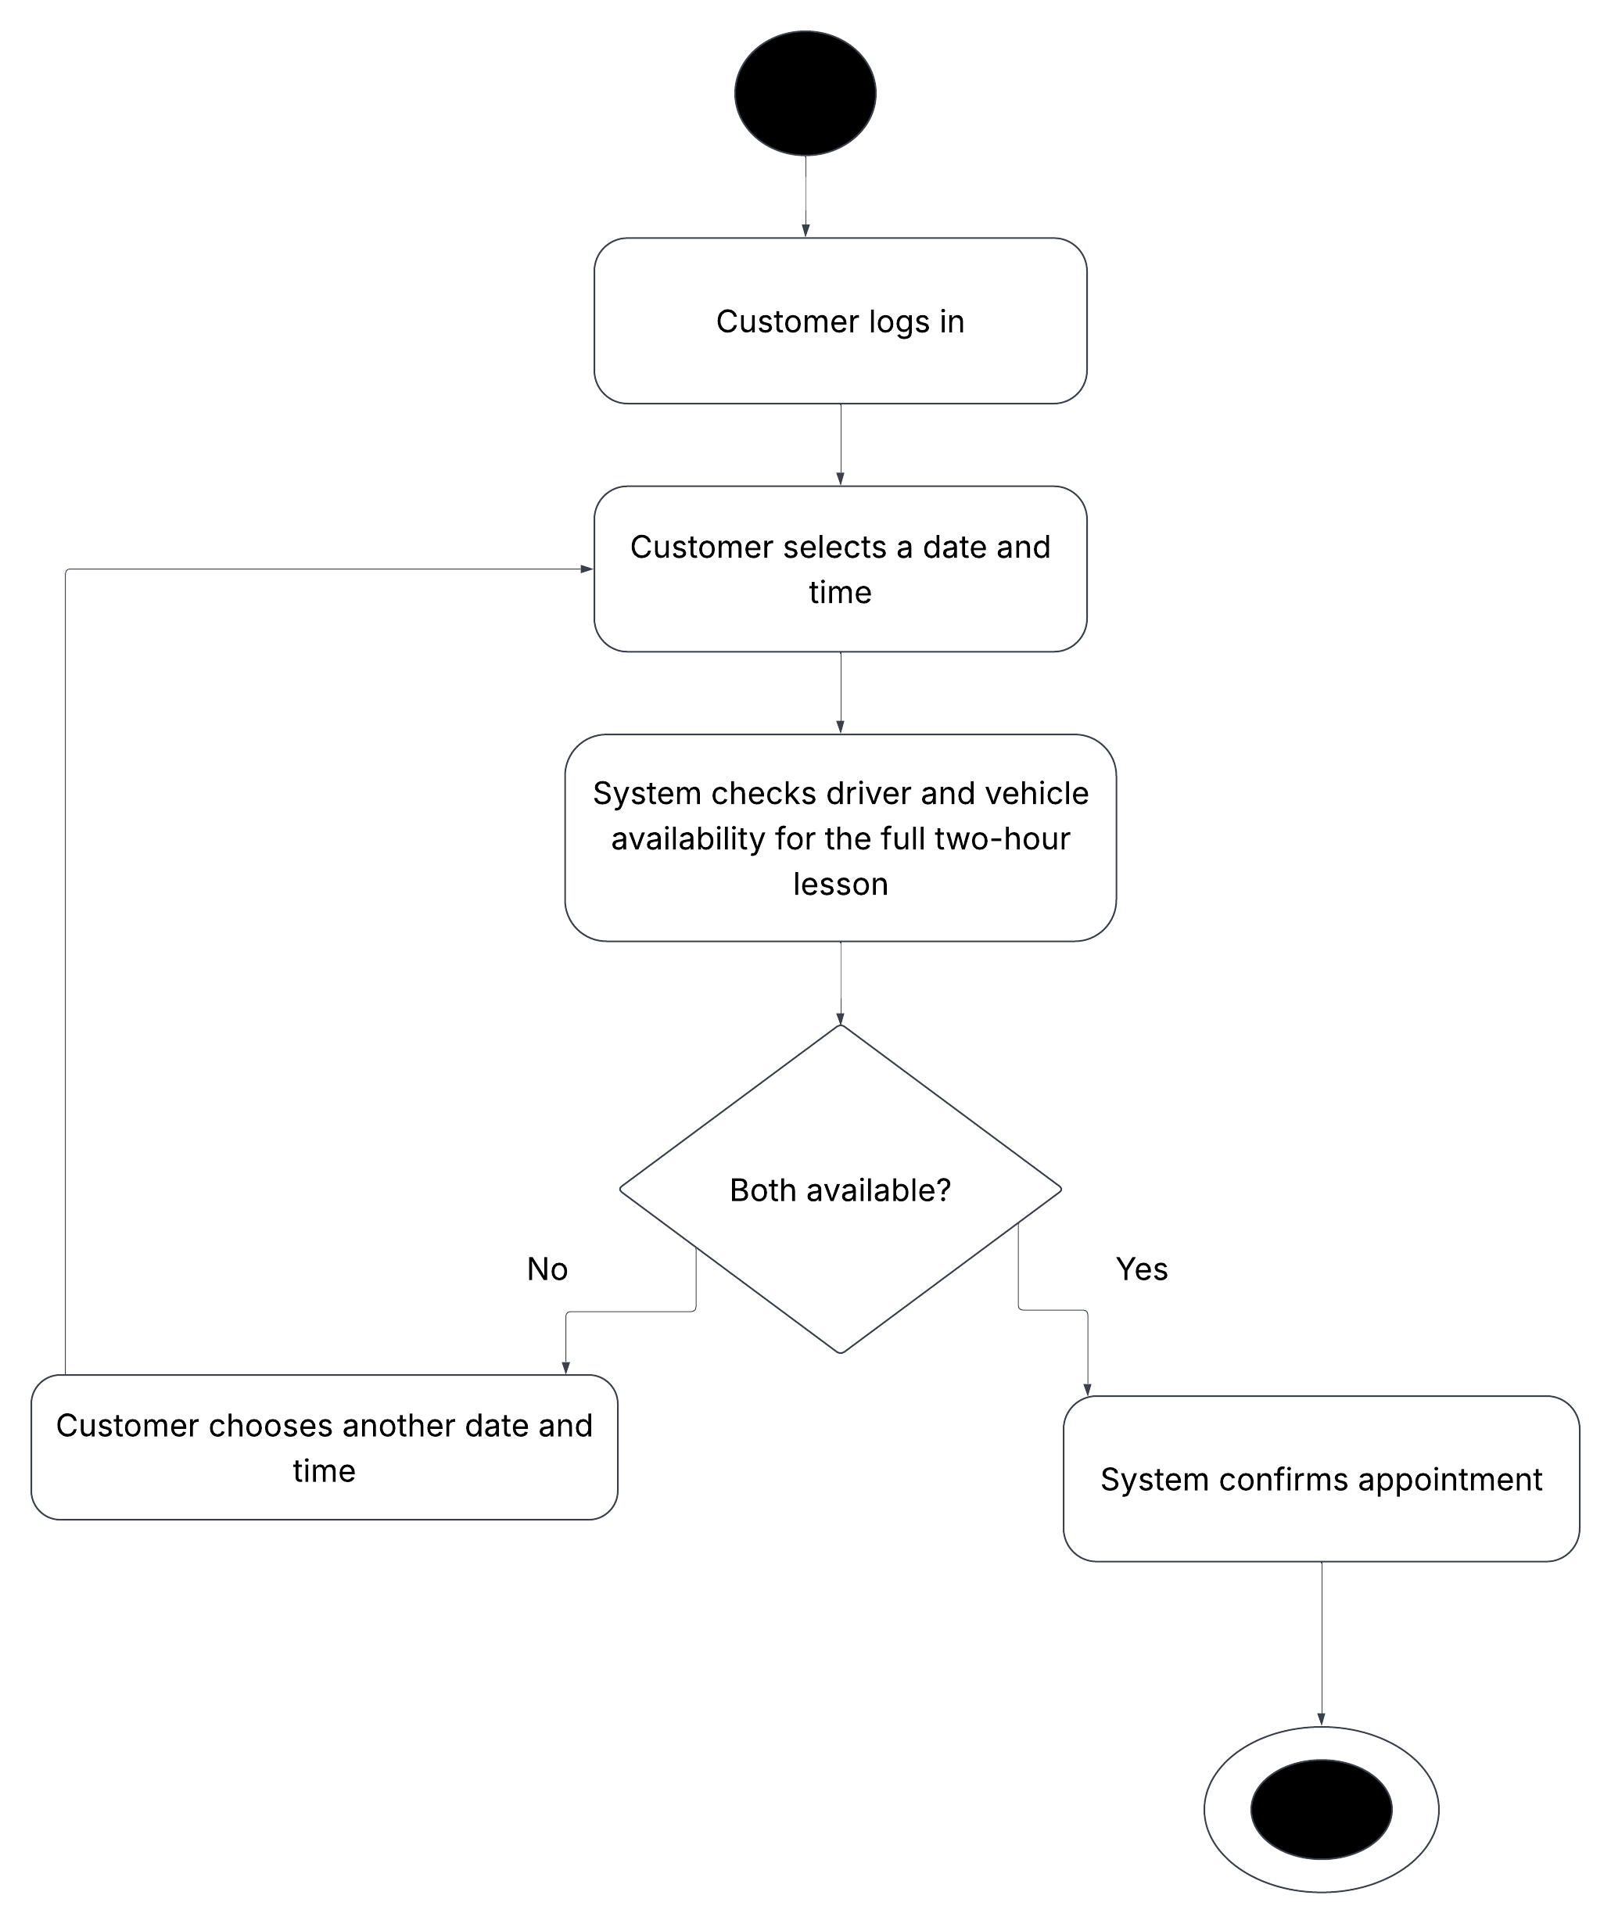

UML Sequence Diagram
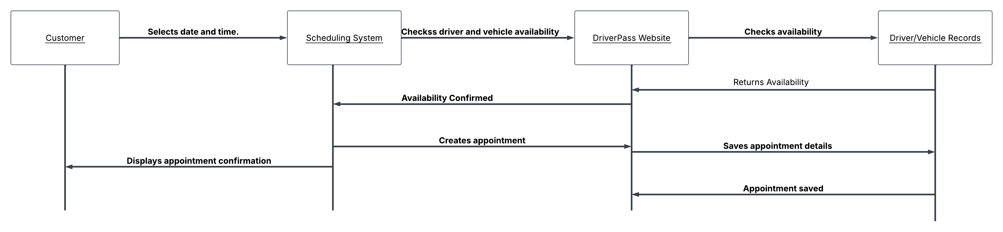

UML Class Diagram
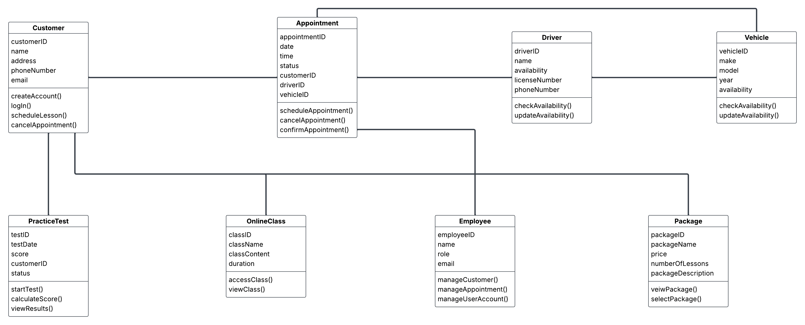

Technical Requirements
The DriverPass system will need to be a website that customers and employees can use on a computer or phone with internet access. Customers should be able to make an account, pick a package, schedule driving lessons, take practice tests, and access online classes.

The system will need a database to keep track of customer information, appointments, drivers, vehicles, packages, and practice test results. This will help keep everything organized and make it easier for employees to find the information they need.

The system will also need to check if a driver and vehicle are available before an appointment is scheduled. Employees should be able to manage customer information and appointments, while customers can check their lessons and practice test results.

Security is important because the system will store personal information. Users should have to log in to access their accounts, and only employees with the right access should be able to make certain changes. The system should also keep records of appointment changes so DriverPass can see what has changed and who made the change.

DriverPass will need reliable web hosting, internet access, and enough storage to keep its information. The system should also have regular backups in case information is lost. The website and training materials will need to be updated when needed, especially when the DMV changes its rules or practice test information.

